110年計算機結構 第7次小考

1. (30%) Consider the design of the control circuit FSM for the accumulator-based CPU defined by Fig.1, Fig.2 and Fig.3. Assume that it must have the 10 internal states. S0:S9 defined by Fig.1 and is to be implemented as a Moore machine using the one-hot method with D flip-flops. Assign the hot variable Di to state Si and obtain a complete set of next-state Di. (give the equation of D0 : D9)
2. (30%) Consider the design of the control circuit for the accumulator-based CPU defined by Fig.1, Fig.2 and Fig.3. Give the ROM table (such as Figure 5.36) and its micro-programmed control unit (such as Figure 5.37).

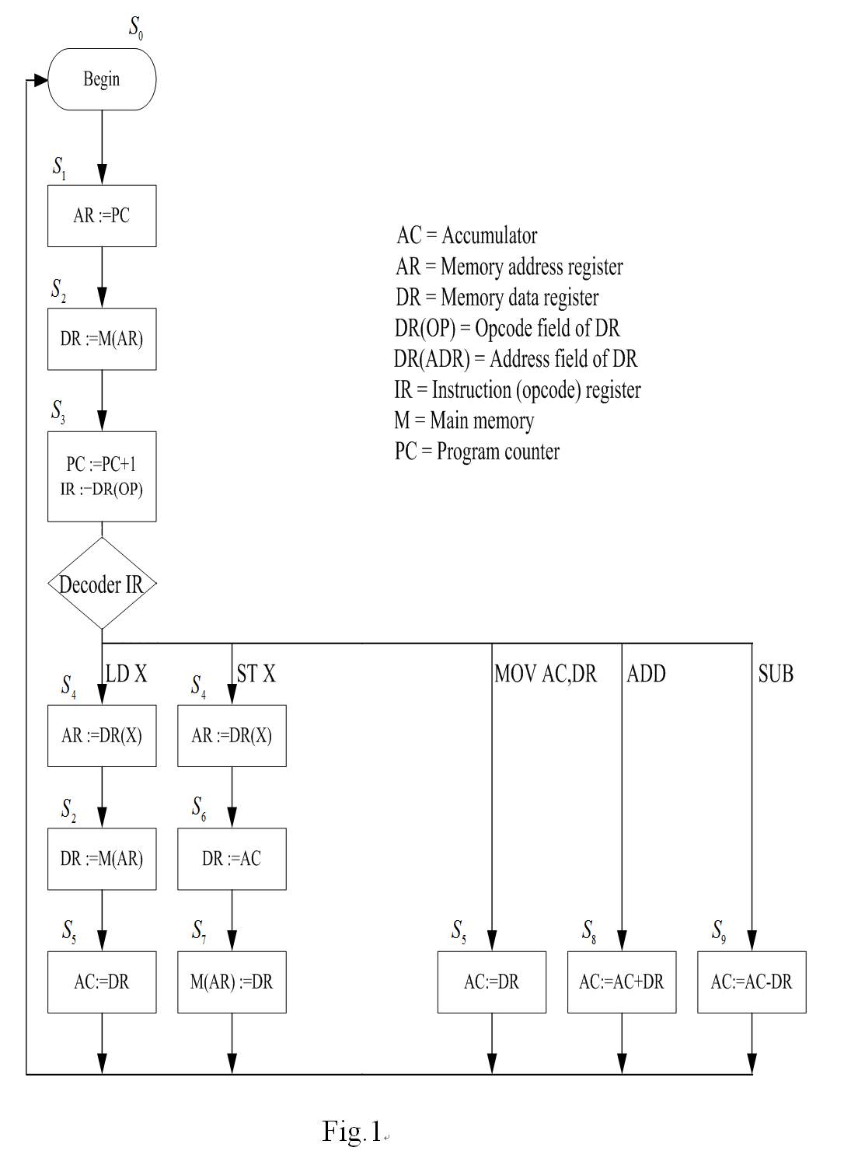

|  |  |  |
| --- | --- | --- |
| **Control Signal** | | **Operation controlled** |
| C0 | AR := PC | |
| C1 | DR := M(AR) | |
| C2 | PC := PC+1 | |
| C3 | PC := DR(ADR) | |
| C4 | IR := DR(OP) | |
| C5 | AR := DR(ADR) | |
| C6 | DR := AC | |
| C7 | AC := DR | |
| C8 | M(AR) := DR | |
| C9 | AC := AC + DR | |
| C10 | AC := AC - DR | |

Fig.2

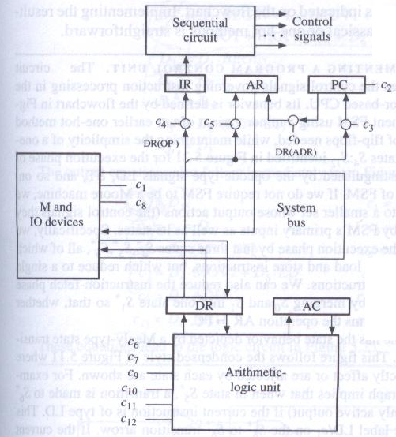

Fig.3